3.1 Functions
Name ________________

Rewrite each of the following arrow diagrams as a set of ordered pairs.

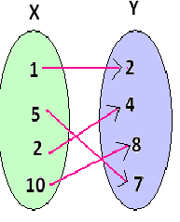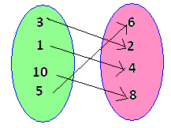
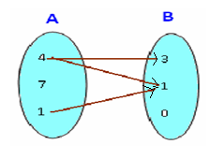

For each of the following arrow diagrams, determine if it is a function or not. If it is a function, determine if the function is one to one and/or onto AND draw the arrow diagram of its inverse (even if not a function).

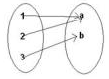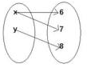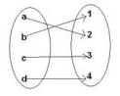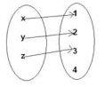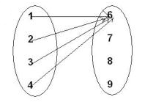

Draw the arrow diagram of the following sets:
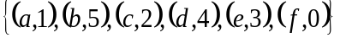 | 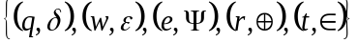 | 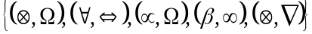

For each of the following sets, determine if it is a function from 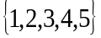 to 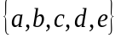 or not. If it is a function, determine if the function is one to one and/or onto AND write set of order pairs of its inverse function (even if it is NOT a function).

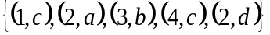 | 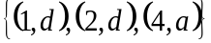
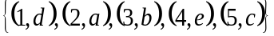 | 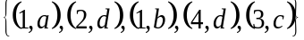
Determine whether each function is one to one, onto or both. Prove your answer.
- 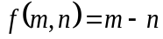 with domain Z x Z with codomain Z.

- 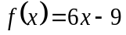 with domain and codomain the set of all real numbers.

Assuming that the codmain of each of the following functions has been properly restricted (Let range = codomain), find the inverse of the following:
- 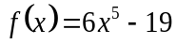

- 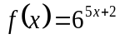

Given the following functions:
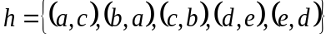, 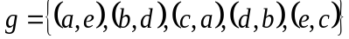 and 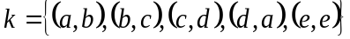
Find the following compositions (Write in set notation):
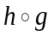 | 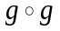 | 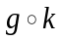
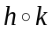 | 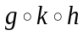 | 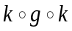

Decompose each function 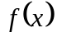 into simpler functions 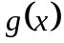 and 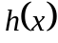 such that 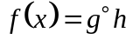.
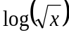 | 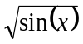 | 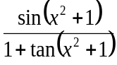

3.2 Sequences and Strings

For the sequence: 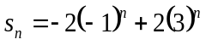, 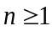 find (without a calculator).
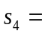 | 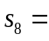 | 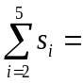
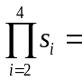 | Find a formula for 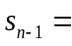 | Find a formula for 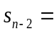
Show 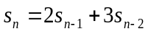

For the sequence: 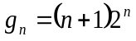, 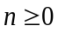 find (without a calculator).
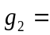 | 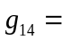 | 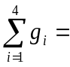
List the first five terms of the for the subsequence obtained by taking the second, fourth, sixth, eight, … terms. | Find a formula for the expression n_{k}. | Find a formula for the k^{th} term of the subsequence.
Show 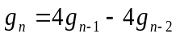, 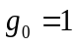,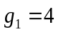

Compute the given quantity using the strings
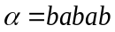 | 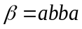 | 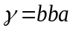
- 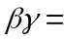 | - 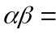 | - 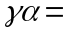
- 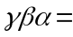 | - 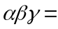 | - 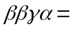
- 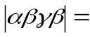 | - 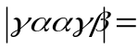 | - 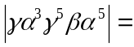

List all substring of the string: aaccb

3.3 Relations / 3.4 Equivalence Relations

Determine whether each relation on the set of integers is reflexive, symmetric, antisymmetric or transitive. In addition, denote if the relation is a partial order or equivalence relation.

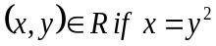 | 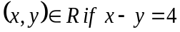 |  | 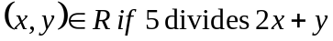

Consider the following relation: 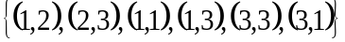

Which ordered pairs need to be added to the relation for the relation to be?
- reflexive
- symmetric
- transitive
- an equivalence relation
- which ordered pairs need to be deleted for the relation to be antisymmetric

3.5 Matrices of Relations

Find the matrix of the relation from X to Y relative to the ordering given.
Ordering of 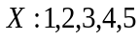  Ordering of 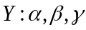 | Ordering of 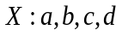  Ordering of 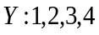

Using a calculator:
- Find the relation 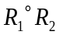 if 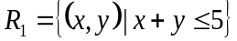; 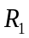 is from X to Y; 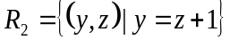; 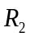 is from Y to Z; ordering of X, Y and Z: 1, 2, 3 ,4, 5

For each of the following Matrices, determine if the relation represented by the Matrix is reflexive, symmetric or transitive.

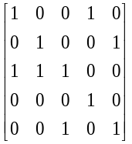 | 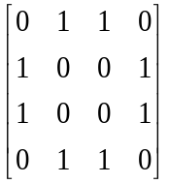
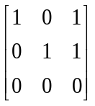 | 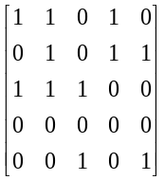

The following Matrix is not reflexive. Which ordered pairs need to be added to the Matrix/relation making the relation/matrix reflexive? | 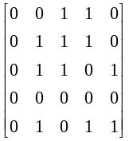
The following Matrix is not symmetric. Which ordered pairs need to be added to the Matrix/relation making the relation/matrix symmetric?

The following Matrix is not transitive. Which ordered pairs need to be added to the Matrix/relation making the relation/matrix transitive?

There is still more

Consider the following relations given by each table.

Rooms |  |  |  | Courses
max capacity | room | dept |  | dept | class | sections
100 | A0 | Mathematics |  | Mathematics | Trig/Precal | 3
40 | A1 | Mathematics |  | Mathematics | Algebra II | 3
40 | A2 | Mathematics |  | Mathematics | Calculus I | 2
40 | A3 | Comp. Sci. |  | Comp. Sci. | CS 1 | 1
100 | B1 | Foreign Lang |  | Foreign Lang | French 1 | 2
40 | B2 | English |  | English | AP Eng Lit | 1
100 | B3 | English |  | English | Bible as Lit | 2

Instructors |  |  | Prerequisites
dept | instructor |  | prerequisite | class
Mathematics | Gauss |  | Algebra II | Trig/Precal
Mathematics | Euler |  | none | Algebra II
Mathematics | Fermat |  | Trig/Precal | Calculus I
Comp. Sci. | Gates |  | Algebra II | CS 1
Foreign Lang | Le Peregrine |  | none | French 1
English | C.S. Lewis |  | none | AP Eng Lit
English | Tolkien |  | AP Eng Lit | Bible as Lit

Write a sequence of operations to answer the query. Also provide an answer to the query.

- Find all English instructors.

- Find all instructors who can teach in room A0.

- Find all classrooms in which Bible as Lit can be taught.

- Find all Departments with classrooms that can hold 100 students.

- Find all classes that C.S. Lewis can teach.

- Find all class and the number of sections for any class with no prerequisites.

